Contributor: Roxanne Doyen

**Matta, Roberto**

Born: 1911 - Santiago de Chile; Died: 2002 - Civitavecchia Italy

Chilean architect and artist Robert Matta Echaurren is considered one of the most important figures of the **Surrealist Movement**. His paintings combine Latin American, European and American influences. In 1932, Matta decided to leave the politically unstable Chile to work for the French architect **Le Corbusier** in Paris. Disappointed with the architect’s rationalistic ideas, Matta explored the Parisian art world and met many members of the Latin American literary avant-garde, including **Frederico Garcia Lorca** and **Pablo Neruda**, who introduced him to **Salvador Dalí** and **André Breton**. Both encouraged Matta to draw and paint instead of being an architect. In 1937, Matta participated in his first Surrealist exhibition. The artists’ earliest works were abstract crayon drawings, showing organic patterns and microscope views of plants. In 1938, he transitioned to oil paintings. As an architect Matta believed that architecture should create free, dynamic spaces. An example is *Composición,* where he used drawing to expand the visual fields and create interior landscapes, also known as *inscapes*, in which he tried to dissolve the boundaries of surfaces to find the internal world of the human being, or the human psyche.

Matta created spatial paintings with indistinct forms, trying to let the objects emerge and float freely on his canvases. When the political climate in Europe changed due to the Second World War, Matta moved to the United States. Around 1940 he met young New York School artists, like Jackson Pollock, Arshile Gorky and Robert Motherwell. In this period Matta’s artwork became a mixture of abstraction, figuration and multi-dimensional spaces. His aim was to explore his internal world and mix it with an active engagement in the external world. Matta called this *Social Morphologies.* His art appears to be ‘in process’, meaning that it seems to be unfinished, or open to additions and alterations as you can see in his painting *Morfología psicológica* (1939)*.* The ‘accident’ factor in his paintings had a big influence on the Abstract Expressionist movement in the United States. And although Matta never saw himself as a member of this group, artists refer to him as the founding father of Abstract Expressionism.

It was not until the 1950s and 1960s that Matta returned to his native country Chile on a regular basis. His work was without a doubt influenced by Latin American culture and artists like Mexican painter and muralist **Diego Rivera**. Matta also started to use politics and sociology in his artworks and painted murals to support left-wing politicians such as Salvador Allende. Besides that, Matta was very interested in Pre-Columbian astrologic calendars and combined these with modern science and urban life. Abstract objects were brought together into suns and light waves that shot off in different directions at once. Matta was a Surrealist artist who took on political, social and spiritual themes and mixed them with the visionary landscape of the human being’s unconscious.

Roberto Matta died in Civitaveccia in Italia in 2002. Matta inspired his family as well, since four of his six children became artists. One of them, **Gordon Matta-Clark** is famous for his socially conscious work with an architectural approach, inspired by his father’s own work. Matta participated in the *Documenta II* (1959), *III* (1964) and *VI* (1977) in Kassel and won several prestigious international art prices, like the *Premios Príncipe de Asturias* in 1992.

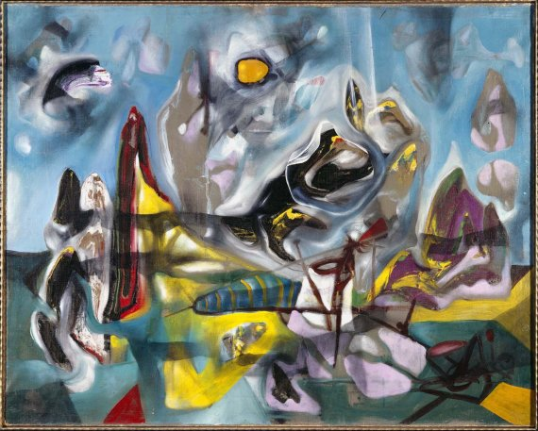

*Morfología psicológica* (1939)

<http://www.museoreinasofia.es/coleccion/obra/morfologia-psicologica>

**Further Reading:**

---- (1964). *Matta.* Catalog of an exhibition held at the Stedelijk Museum Amsterdam, Jan. 17 - Mar. 2, 1964. Amsterdam: Stedelijk Museum.

Carter, C.L. (1997). *Matta: Surrealism and beyond.* Exhibition Catalog. Milwaukee: Haggerty Museum of Art, Marquette University.

Giunta, A. (1999).  *Pintura Latinoamericana.* Buenos Aires: Ediciones Banco Velox.

Lucie-Smith, E. (2004) *Latin American Art of the 20th Century*. London: Thams & Hudson

Sullivan, E.J. (2000) *Latin American Art in the Twentieth Century.* New York: Phaiden Press Inc.

---- (date unknown). Matta (1960-1970). Humanized Architecture. *http://www.museoreinasofia.es/sites/default/files/salas/informacion/420_matta_eng.pdf*

**List of Works:**

Roberto Matta, *Morfología psicoógica,*  1939, oil on canvas, 72,4 x 92 cm. Museo Reina de Sofia Madrid.

Roberto Matta, *Water,* 1939, oil on canvas, 71 x 90 cm, Colección privada, USA.

Roberto Matta, *Nacimiento de América,* 1952, oil on canvas, 208 x 296 cm, Museo de Arte Contemporáneo, Santiago de Chile.

Roberto Matta, *Composición,* date unknown, before 1964, Oil on canvas, 48 x 57 cm, Museo de Arte Contemporáneo, Santiago de Chile.